First of May 2015: Understand and fight the demons of imperialism, bureaucratic capitalism and semi-feudalism!
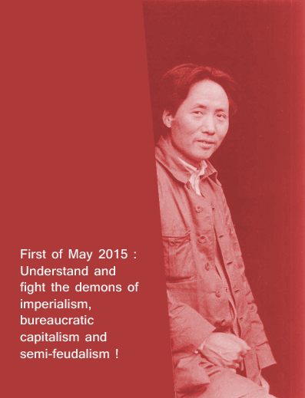
In the famous painting “The School of Athens” by the Renaissance painter Raphael, we can see Plato and Aristotle as the central figures : Plato points his index finger to the heavens, calling to see beyond matter, whereas Aristotle points down to earth with his hand.
Five hundred years afterwards, we can see that we have the same contradiction between idealism and materialism. The images of the religious barbarians pointing to the heavens with their index to justify their senseless killings staged in sordid videos have caused a terrible trouble in the democratic minds.
The spectre of the Middle Ages, of antiquity with its slavery and its murders, shows his ugly face. It is a challenge to progress, to the cause of humanity advancing in culture, rationality, science. It is an attack against the dignity of civilization.
And it didn’t happen by accident, or because imperialist countries organize “conspiracies” : the roots for barbarity are based on the semi-feudal semi-colonial nature of the majority of the countries in the world today.
Only in a few countries did capitalism manage to develop itself in its natural way, moving from its liberal form to the domination of the monopolies, becoming imperialism, in a complex process, across twist and turn.
In the others countries, where the majority of the people of the world lives, religions and nationalism as strong irrational tools used to mobilize the masses in a reactionary way, because society is driven by a bureaucratic bourgeoisie, born from the submission to imperialist countries, and allied to different feudal forces which maintained their structures.
Hundred years ago, there was the Armenian genocide, and still it is not recognized by the Turkish state despite the fact that its new government is Islamist : it is because the bureaucratic capitalism in this country has become more powerful, but still depends on the alliance with feudal forces made at the very beginning of the secular regime.
We can see the same process in India, with the successes of the Hinduist most reactionary forces taking the control of the government ; the urbanization of the country and the development of bureaucratic capitalism do not abolish semi-feudalism, on the contrary !
Semi-feudalism has only change its form. That explains also why Islamism could become such a strong force in countries like Tunisia, Iraq, Syria, Egypt : beyond the secular form of the regime previously, the foundation of it is semi-feudal semi-colonial.
Inter-imperialist struggles play here of course a major role, imperialists supporting bureaucratic factions acting to favor them against others.
During the 1960’s-1980’s, the peoples of the world had to struggle against the partition of the world of the two superpowers – the USA and the social-imperialist USSR – now they have to understand in the same way the bloody games played by imperialists, even trying to divide countries, like in Ukraine for example.
The general crisis of capitalism can only bring more inter-imperialist struggles, more imperialist wars. In the imperialist countries themselves nowadays, selfishness and individualism are used to promote nationalism and its desire to transform the country in an aggressive fortress in the context of “globalization”. Despair provokes escape in drugs and alcohol, pogromist postures, trends to merge nationalism and “socialism”.
At the same time, multiple are the aggressions which disfigures the Earth on a global scale : from climate change to tremendous deforestation, from massive urbanization to the acidification of the ocean.
The world masses are aware of this, but they don’t find a way to be united and to choose the path of the red star. The lack of a communist strategic proposal disorients the world masses, which want real democracy, but don’t know how to achieve it.
In this context, such a position of retreat of the world revolution permits capitalism to modernize itself, in particular in the dependent countries, where feudalism change its form, to be more conform to the development of bureaucratic capitalism. In the same way that we find a difference between a superpower like the USA and the imperialist countries of the second category – like France, Germany or England – we find according to that differences among the dependent countries.
Whereas a country like Iraq falls into the horror of feudal murders, a country like Brazil knows an agro-industrial development through a bureaucratic capitalism acting to serve the imperialist interests.
Semi-feudal semi-colonial countries like Qatar and Saudi Arabia play an open aggressive policy, helping reactionary forces ideologically and materially to establish factions supporting them ; the Arab spring was no “revolution”, but a battle between bureaucratic bourgeoisies. This shows the correctness of Akram Yari and Siraj Sikder’s thesis on the possibility for an oppressed country to be a colonizing force and to have an expansionist character.
Everything obeys to the law of dialectics, and this evolution testifies of the development of the productive forces, in such a manner however that it means more exploitation, more oppression, more imperialist wars, that it’s a threat to the nature on our planet, to the possibility of a happy life, full of joy and culture, for the world masses.
Nevertheless, it would be a mistake to believe that this negative aspect is the major trend in our world. In each country, they are people working to understand the situation in a scientific way. They try to analyze the current situation, be it on the international level as on the national level.
When they are genuine revolutionaries, as the product of the class struggles of their own country, when they understand that they must be in the tradition of the International Communist Movement, then they do contributions that permit to move in the direction of producing a guiding thought.
This question of the guiding thought is the most important one in each country. As the Communist Party of Peru explained it in the document “On Gonzalo’s thought” :
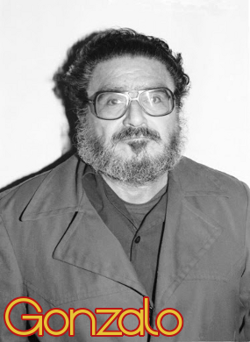
“Revolutions give rise to a thought that guides them, which is the result of the application of the universal truth of the ideology of the international proletariat to the concrete conditions of each revolution; a guiding thought indispensable to reach victory and to conquer political power and, moreover, to continue the revolution and to maintain the course always towards the only, great goal : Communism.”
In the famous interview he gave, the leader of the Communist Party of Peru, Gonzalo, tells us here also:
“In Engels’ view, it is necessity that generates leaders, and a top leader, but just who that is is determined by chance, by a set of specific conditions that come together at a particular place and time. In this way, in our case too, a Great Leadership [Jefatura] has been generated. This was first acknowledged in the Party at the Expanded National Conference of 1979.
But this question involves another basic question that can’t be overlooked and needs to be emphasized : there is no Great Leadership [Jefatura] that does not base itself on a body of thought, no matter what its level of development may be.
The reason that a certain person has come to speak as the Leader of the Party and the revolution, as the resolutions state, has to do with necessity and historical chance and, obviously, with Gonzalo Thought.
None of us knows what the revolution and the Party will call on us to do, and when a specific task arises the only thing to do is assume the responsibility.”
The first of May is an historical day : it is the one of the pride of working class, the one of the honour of the red flag. The word as we know it is full of sufferings and of transformations, the main aspect of our epoch is the production of guiding thoughts, which are carried by revolutionaries to build the revolutionary paths in each country.
Such a revolutionary path consists in People’s War : the armed mass mobilization to break the old state and install the new one, carrying the revolutionary program of New Democracy in the semi-feudal semi-colonial countries, of Socialism in the capitalist countries.
It is here to stress the importance of the theory to defend all the communist conceptions, against all the tendencies to make “compromise” with imperialist values, to integrate post-modernist conceptions, to promote ultra-leftist positions, to negate the teachings of the Communist International especially in the lessons of the People’s Front against Fascism.
The epoch of decay of capitalism is a tormented one ; only a strong ideological headquarter can face the many faces of opportunism, reformism, fascism, of the counter-revolution. We remember here what happened to the heroic people’s war in Nepal, which was betrayed.
The consequences for the Nepali masses are terrible ; their cause was stabbed in the back by revisionism. The terrible earthquake that just happened near Kathmandu brought many deaths that could have been avoid with another social development allowing more robust constructions ; we have to remember also here the intolerable and dramatic situation of the Nepali workers working in Qatar.
It is important to note that nowadays, centrists having tried to mask the revisionism in Nepal, protecting its leader Prachanda and his “peace agreement”, do everything they can to avoid any criticism. Genuine Maoists have said as soon as 2006 that there was a major problem in the line of the Communist Party of Nepal (Maoist), whereas centrists still greeted the “people’s war” years afters there was no people’s war any more and when it was clear since long that revisionism had won there.
The position of centrists about Nepal testifies here their negation of the concept of bureaucratic bourgeoisie ; this shows the importance of dialectical materialism as a science.
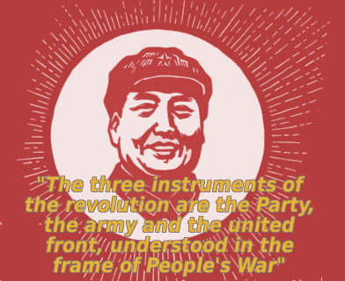
We wish here to emphasize the following elements :
1. Contradiction is the only fundamental law of the incessant transformation of eternal matter. Dialectical materialism is the science of understanding this law and the ideological core of the communist movement.
2. Without revolutionary theory there can be no revolutionary movement. Spontaneity doesn’t lead to revolution ; there is a need for a Marxist-Leninist-Maoist Communist Party that firmly applies independence, autonomy and self-reliance.
3. The history of all hitherto existing society is the history of class struggles. The masses make history and the Party leads them through the direction of a guiding thought, application of the communist ideology to the concrete conditions of a given country.
4. Capitalism in its liberal form became imperialism characterized by the hegemony of the monopolies, tending to fascism and imperialist wars. The building of an united antifascist People’s Front, as underlined by the Communist International, forms the condition for the democratic foundation for establishing socialism as dictatorship of the proletariat.
5. Capitalism which is being developed in the oppressed nations by imperialism along with different degrees of underlying feudalism, or even pre-feudal stages, is bureaucratic. The New Democratic Revolution, as a joint dictatorship based on the worker-peasant alliance, smashes the semi-feudal elements, opening the way to overthrow bureaucratic capitalism, as democratic foundation for establishing socialism.
6. The three instruments of the revolution are the Party, the army and the united front, understood in the frame of People’s War as the universally valid military theory of the international proletariat. Invincibility of the People’s War is inevitable as it represents the new against the ancient, as obligatory resolution of an antagonistic contradiction.
7. The communist ideology prevails in all the intellectual and cultural fields, through socialist realism in the arts and literature and Marxist philosophy i.e. the law of contradictions in science. Taking power means to take it at all levels of society, as shows it the masterful example of the Great Proletarian Cultural Revolution.
Maoism is not a “tool” to support rebellion, but the materialist understanding of a situation and therefore the revolutionary application of the communist cause by the proletariat: class struggle, conquer and to defend power with the People’s War in each country, as part of the world socialist revolution!
On this First of May, 2015, we call therefore again the basic positions of the genuine communists:
Long live Marxism-Leninism-Maoism; long live Maoism as the most develop form of dialectical materialism!
Uphold, defend and apply, principally apply, Maoism!
Struggle for the generation and the application of the guiding thought in each country, to initiate and develop the People’s War !
People’s War until Communism!
Organization of the workers of Afghanistan (Marxist-Leninist-Maoist, principally Maoist)
Marxist-Leninist-Maoist Center [Belgium]
Communist Party of France (marxist-leninist-maoist)

