IN SOLIDARITY WITH THE JUST STRUGGLE OF MILITANT PEASANT FARMERS AND AGRICULTURAL WORKERS IN INDIA

We extend our revolutionary solidarity and support to the militant peasant farmers and agricultural workers joining together as a peoples' united front, resolved in the struggle to force the repeal of the reactionary and anti-people laws imposed by the Indian ruling classes led by the Modi government.
The protests began in mid-August 2020 in northern India in anticipation of the introduction of the three laws designed to remove all legal barriers to the spread of the influence of rapacious finance capital and corporation in the agricultural sector. In September 2020, ignoring the protests, the Modi Government using its majority position in the parliament, circumventing the parliamentary procedures pushed through the three ruinous bills. These controversial bills remove all barriers to the extension of India-WTO agreements signed in 1995 to the agricultural sector. This can only mean the wholesale handover of the Indian agricultural industry to the local and international financial institutions to further exploit and plunder.
Enraged by these anti-people bills, tens of thousands of farmers, particularly from the northern state of Punjab, after protesting in vain for almost three months, on November 26, 2020, began their march to New Delhi, the capital. The reactionary Modi government responded by deploying paramilitary troops armed with water cannons and tear gas and protected by barricades, razor wire and deep trenches dug into the freeways at the borders of the capital blocking the farmers' journey to the centre of the city. The militant farmers fought off the violent attempts and held their ground against the authorities' brute force.
Since then, the protests have spread across the whole country and represent the largest ever mass mobilisation of farmers in India to date. Currently, an estimated 500,000 peasant farmers and agricultural labourers are encamped surrounding the city. Led by an alliance of 32 farmers’ and workers’ unions, the historic protest has swelled into an almost 20km stretch of camps with community kitchens, public libraries, film screenings and platforms for political meetings. So far, over 90 people have died during the protests. Some have died because of the cold, and some have committed suicide in protest as a political statement.
So far, eleven rounds of fruitless discussions and negotiations between the farmers' representatives and the government bodies have taken place. While the government aims to exhaust the protests, the farmers are determined that they will not return to their homes unless these laws are repealed.
On January 26, hoisted as "India's Independence Day" by the Indian ruling classes, the protest organisers had called for peaceful rallies and marches. They had negotiated agreed routes with the police. But the roads for the demonstrations by the masses were blocked by the authorities. During the mayhem, a group of militant farmers, notwithstanding the police violence and the blockades, broke away and symbolically occupied the Red Forth, where these ceremonies usually take place. They thus showed nothing can stop or hinder their resolve.
The upsurge and the resilience of the militant protests of the peasant farmers and its spread across the country is a significant blow to the Modi government and it's policies of "divide and rule" as undisguised attacks on the working class and other toiling masses in India. During his term in office, furling the flag of Hindutva fascism, Mr Modi has unleashed many retrogressive measures aggravating social division and communal violence. Yet, at these protest gatherings, peasant farmers from all origins and from different communities, including Hindu, Muslim and Sikhs, live together, share the same food and shout the same slogans in their rallies. They stand resolutely, shoulder to shoulder against the authorities. Women, the backbone of the rural economy, have played a frontline role in the struggles. Dalits, typically undertaking the hardest manual labour in the countryside, have played a significant role in these struggles.
While the Indian ruling classes claim India to be the “largest democracy” in the world today, they deploy the most brutal repression against all forms of protest against the government. They unleash government backed Hinduvta fascist thugs to attack and brutalise the unarmed peasant farmers and protestors physically. Particularly during the last three weeks of the protests, the regime has cut internet and mobile access to New Delhi and surrounding areas. It has forced the closure of many social media channels that spread the news of the protests. The reactionary Modi Government has increasingly resorted to using "sedition laws" against protestors. These laws dating back to the 1870s when India was under British rule and are now revived to intimidate protesters and contain their struggles.
Yet despite all repression, the militant farmers continue in their fight. On February 18, 2021, they launched further protests calling a national day of protest and occupations of the railway stations to express their determination and resolve in continuing their struggles.
The struggle of the Indian peasant farmers against such reactionary policies today is unprecedented in size and the dimension of the resistance. But it is not a new phenomenon. The agricultural sector in India, which largely consists of smallholding and subsistence farming, is the source of income for over 50% of the population. As such, it has always been sensitive to such reactionary machinations by the ruling classes both during the British direct rule and since 1947 when power was passed to the Indian ruling classes.
Historically, Punjab was the epicentre of the notorious "Green Revolution" unleashed in the 1960s. The "Green Revolution" in India was the localised version of a general policy sponsored by US imperialism following the Second World War. It was designed as a comprehensive policy to stifle the influence of communists leading peasant revolutions sympathetic to the Soviet Union and the Peoples' Republic of China led by Mao Tse-tung. It was aimed at putting an end to the revolutionary transformation of feudal relations through a revolutionary process and to impose a state-sponsored reform. Particularly in Punjab, following independence in 1947 and throughout the 50s and 60s, there were significant militant struggles for land reform and agrarian revolution by peasant movements led by communists. The "Green Revolution" in India followed similar examples in Latin America (Guatemala) and south-east Asia (Philippines), Middle East (Iran and Turkey) to stop the spread of communist influence. It was hoisted as an initiative to overcome “famine and food shortages”. This was applied to agriculture where the US supplied high yield fertiliser hungry seeds to increase the production of wheat, rice and other cash crops, introducing a basic form of industrial agriculture. With a Keynesian outlook, the Indian government subsidised and provided minimum prices for these agricultural products. The "Green revolution" ushered in greater and deeper dependency on the US and the supply of seeds, chemical fertilisers, and other farming products.
While the reactionary ruling classes in India and the US imperialism and it harbingers hail this as a success story, the effect was seen and felt on the ground taking the processes of dispossession and pauperisation of the large numbers of peasant farmers to new dimensions. The "Green revolution", in effect, was aimed at integrating the feudal relations with the comparator relations maintaining the existing social relations, the class structure, and the caste system of oppression intact.
Today, the Modi government is hailing the introduction of these laws as the "Green Revolution 2". It is claiming that this will double the farmers' wages and income. Yet all statistics show otherwise. With inflation at a steady average of 7.5%, farmers' income has steadily decreased during the last decade. As a barometer of the worsening conditions of life, rising debt and bankruptcy of the peasant farmers, the suicide rate has taken a dramatic rise. In September 2020, the Indian parliament heard reports indicating that in 2019 alone, the number of recorded suicides amongst farmers and daily wage earners was 42,480 people. Some estimates show the number of suicides is steadily rising and that during the last decade alone, a figure close to 300,000 farmers and daily wage earners have committed suicide.
Clearly, the imperialist model of development and its endemic crisis is at the root of the problem. India is considered ripe for further extensive plunder of its resources and markets by imperialist powers and their collaborators. The Indian ruling classes, serving these interests, have at least for the past 25 years strived to introduce “neoliberal” policies and have made every attempt to usher in further instruments to ease the expansion of domestic and international finance capital over the country. Yet, at every turn and every attempt, the ruling classes have faced militant resistance by the people. Clearly, neither their policies designed to auctions off the tribal lands in order to plunder its mineral resources disguised as "Operation Green Hunt", nor the opening of mega-store to the "Indian Walmarts", or the opening of the claws of domestic and international finance capital in the agriculture, facilitated by the latest three bills passed by the government of Mr Modi, can address the crisis of a corrupt, decadent and reactionary system that is long overdue for revolutionary transformation.
The struggle of the Indian peasant farmers in India is an inseparable part of the worldwide struggle of workers and other oppressed against imperialism and reaction. The struggle against colonialism and imperialist domination and for a people's democracy has a long, glorious history in India. The peasant farmers in India carrying on with such militant traditions in their just struggles are certain to attract the support, solidarity and sympathy of all oppressed and proletarian forces at home and abroad. Their persistent fight will undoubtedly contribute to and extend the ongoing revolutionary struggles of progressives democratic and communist forces in India.
We stand shoulder to shoulder with the revolutionary struggle of all workers and other oppressed people in India. We extend our solidarity with the just struggle of the peasant farmers movement in India.
Victory to the oppressed farmers in their just and militant struggle against the imperialist backed reactionary offensive of the Indian state!

TKP-ML International Bureau
February 2021

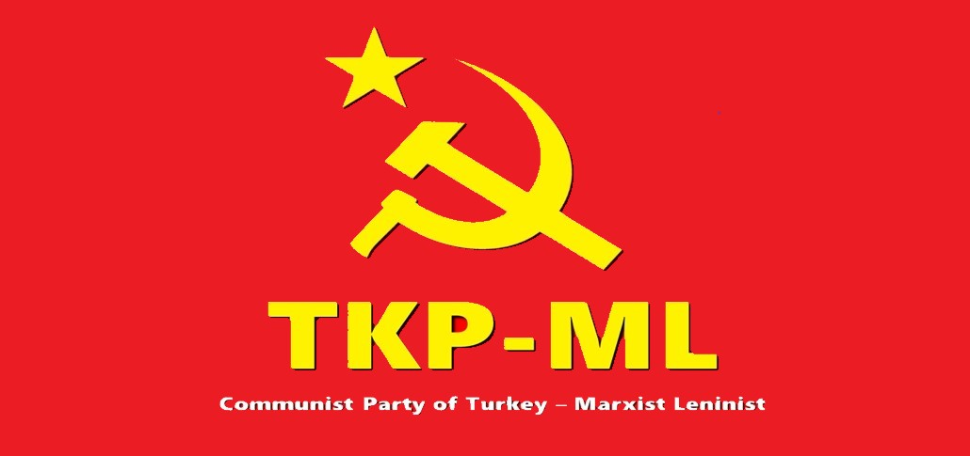
Link: https://www.tkpml.com/tkp-ml-international-bureau-in-solidarity-with-the-just-struggle-of-militant-peasant-farmers-and-agricultural-workers-in-india/

