Condolence message from TKP-ML International Bureau to the comrades of NDFP for the loss of Ka Fidel Agcaoili
Dear comrades,
The unexpected big loss of our comrade Fidel Agcaoili, who had dedicated the largest part of his life to the anti-imperialist, revolutionary struggle, has profoundly saddened us. We want to extend our sincere condolences to his family, friends and comrades. We share your sorrow.
Ka Fidel was a revolutionary who has always been supportive, humble and helpful to his comrades. He was a genuine anti-imperialist, internationalist who was truly concerned about the struggles against reactionary orders worldwide. This was also appearing in his attentiveness and solidarity for the fight against fascism in Kurdistan and Turkey. As comrade Fidel said: "You really have to be good in your ideology. That means, not only reading, but practicing it, understanding it. So you are not talking above, like you're in the clouds. But right here, in concrete reality." He practiced these words by not only studying and reading all the struggles over the world, but also by taking part in the actions on the streets.
Our revolutionary comrade Fidel left traces which will enlighten the path of the struggle for a just and free world. As he said: "I believe that the path I have chosen is the correct one for me. And if given another chance I would still choose the same path." He was leading an example of determination in the revolutionary struggle.
We will never forget the openhearted, warm and comradely approach of Ka Fidel during our last meeting with CPP. We will keep his spirit alive in the international struggle.
On behalf of the Central Committee of Communist Party of Turkey - Marxist Leninist (TKP-ML) and the whole party, we express our comradely respect and tribute to Ka Fidel Agcaoili. We also want to extend our solidarity with the proletariat and the oppressed people of the Philippines. The memory of our fallen comrades will live forever in our common struggle against imperialism and all other reactionaries.
The memories of comrade Fidel will live in our struggle!
Comrade Fidel is immortal!
Long live international solidarity!
Communist Party of Turkey - Marxist Leninist (TKP-ML)
International Bureau
28 July 2020
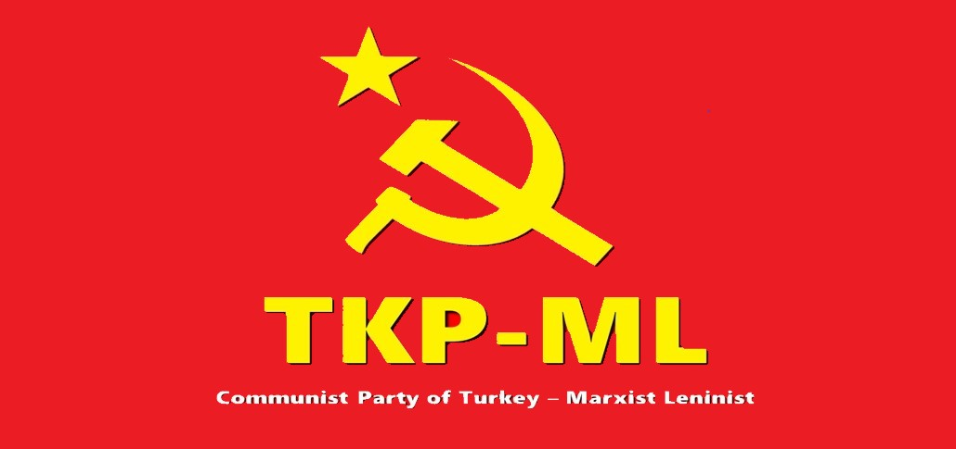
Link: https://www.tkpml.com/condolence-message-from-tkp-ml-international-bureau-to-the-comrades-of-ndfp-for-the-loss-of-ka-fidel-agcaoili/

