1 May 2025: Unity and Struggle!
The day of unity, solidarity and struggle for the working class and oppressed rights was celebrated with enthusiasm and struggle all over the world. Hundreds of thousands of people participated in the 1 May celebrations. Actions were carried out against the exploitation, massacres and oppression of the imperialist capitalist system, primarily by the working class.
May 1st in Istanbul was marked by resistance
In Istanbul, hundreds of people were detained while attempting to march to Taksim on May 1st, the Day of Labour and Solidarity. Students, workers, and women participated en masse in a rally organised in Kadıköy at the call of DİSK and KESK.
May Day in Istanbul was commemorated with actions at two different locations. Students, trade union members, democratic mass organisations and revolutionaries who wanted to march from Mecidiyeköy to Taksim were met with police attacks. The May Day Taksim Organising Committee announced that at least 230 people were detained.
Meanwhile, tens of thousands gathered at a rally in Kadıköy organised by unions such as DİSK and KESK. Students, workers, women and LGBTİ+ individuals voiced their demands on issues ranging from the housing crisis and precarious working conditions to gender inequality and freedom of expression. Speeches at the rally called for joint struggle against the economic crisis, increasing repression, and the obstruction of the right to organise.
Attack on Those Who Wanted to March to Taksim: At Least 500 Detained
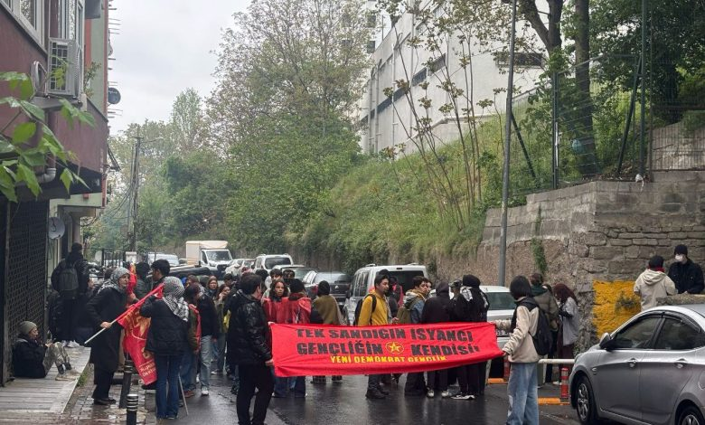
Despite all attempts to ban and obstruct the rally, and the detention of the entire organising committee, the streets of Mecidiyeköy turned into a protest zone. Socialists, trade unions, youth organisations, and university solidarity groups demonstrated their determination to march to Taksim despite police attempts to block them. Police surrounded numerous groups around Mecidiyeköy, attacked those who insisted on marching, and detained them. The Istanbul branch of the CHD announced that the number of detentions had exceeded 400.
In house raids carried out before May 1st, 230 people were also detained.
A large number of marchers who set off from different points in Mecidiyeköy towards the meeting point with banners and slogans were met with police attacks.
A delegation of representatives resisting at the police barricade and groups marching towards Taksim from different points were stopped by a police cordon and detained.
The New Democratic Youth (YDG), which called for a march to Taksim, gathered with its readers in Mecidiyeköy under the slogan ‘The only rebel is the rebellious youth itself.’ The police also attacked YDG readers who started marching towards Taksim.
YDG stated that 18 people were detained in the first attack, and that they dispersed into side streets and held another meeting, after which a second attack took place.
They reported that six people were detained in the second attack and that the police drew their weapons on the readers during the attacks.
Mass rally in Kadıköy: Struggle for a humane life and future
May 1st Unity, Struggle and Solidarity Day was celebrated in Kadıköy Pier Square under the leadership of the Revolutionary Workers‘ Trade Unions Confederation (DİSK), the Public Workers’ Trade Unions Confederation (KESK), the Turkish Chamber of Engineers and Architects (TMMOB) and the Turkish Medical Association (TTB) with the slogan ‘We will win for labour, peace, democracy and justice.’ The rally was held at Kadıköy Pier Square.
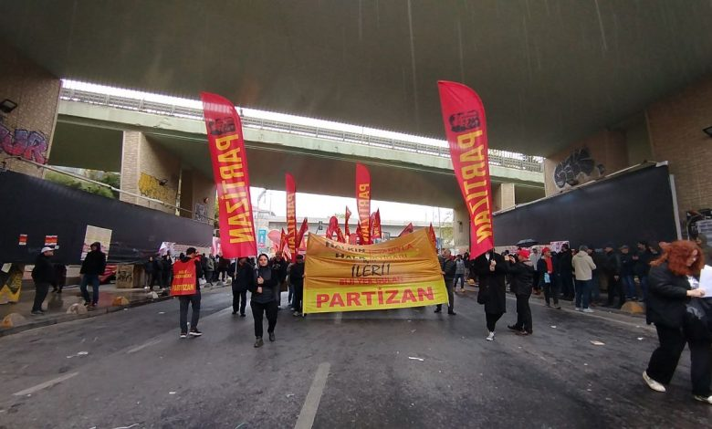
At the Kadıköy rally, the Workers' Labour Union marched behind the main banner, followed by Partizan, SMF, BDSP, İşçi-Sen, Call for a New World, Word and Action, DKD-Der, KÖZ, Odak, Bolshevik Leninists, and Kaldıraç.
In the Söğütlüçeşme branch, KESK, the Workers' Labour Union, Dem Party, TKP, TKH, Pir Sultan Abdal Ataşehir Branch and Sodap marched. In the Haydarpaşa branch, DİSK, TTB, TMMOB, CHP and DSİP marched.
Partizan raised the slogan, ‘With the people's uprising, forward for people's power!’ Partizan demanded the release of Partizan reader Nurgül Uci and Özgür Gelecek reporter Perihan Erkılıç, who were detained in house raids.
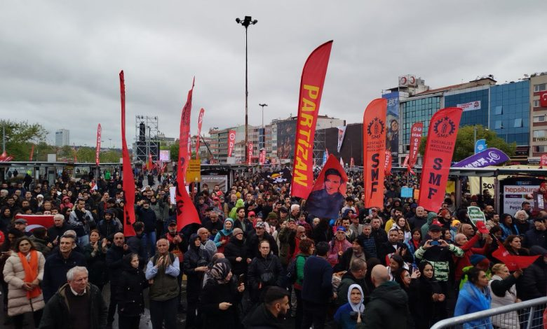
In the Partizan column, slogans such as ‘Long live May 1st, Biji Yek Gulan,’ ‘United workers are invincible,’ ‘Rebellion against fascism, Partizan is the leader of the people,’ and ‘Our leader İbrahim, İbrahim Kaypakkaya’ were chanted. Throughout the march, attention was drawn to the divisive policies of the AKP-MHP and emphasis was placed on popular movements.
At the rally, letters sent by Istanbul Metropolitan Mayor Ekrem İmamoğlu and Selahattin Demirtaş from Edirne Prison were read aloud.
A university student said, ‘Today is the day to be the voice of the workers, labourers and students of this country. The dreams of young people are being crushed in the corners of the country. Instead of the future we dreamed of in the university exams, today we cannot find a place to live.’
Günay Yıldız, one of the Esenyurt Municipality workers who was fired and has been on strike for days, said, ‘This voice is not only mine. It is the voice of those who stand shoulder to shoulder. We stand by our unions. There is no salvation alone; either we are all together or none of us are.’
Speaking on behalf of women and LGBTİ+ people, Hatice Yayla emphasised the invisibility of women's labour and inequality: ‘Being a woman in this country is not just about living in poverty; it is about fighting against all forms of inequality and violence. The struggle for women's rights is inseparable from the struggle for LGBT+ rights. Peace for us is not the silence of weapons; it is equality, justice, and the recognition of our identities.’
The students stated that they had been tortured while being detained in Şişli and voiced this situation with slogans at the rally. The organising committee responded to their slogans with ‘There is detention and torture in Şişli’.
The rally ended with songs in Turkish and Kurdish by Grup Munzur, slogans and halay dances.
May 1st in Ankara: Voices raised against crisis, war, and poverty
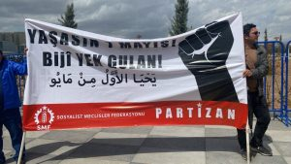
May 1st in Ankara was celebrated with a march and rally from AKM to Tandoğan.
May 1st Labour and Solidarity Day in Ankara was celebrated with a march and rally from the Atatürk Cultural Centre (AKM) to Tandoğan Square. A procession and rally were organised under the leadership of the Revolutionary Workers‘ Trade Unions Confederation (DİSK), the Public Workers’ Trade Unions Confederation (KESK), the Turkish Chamber of Engineers and Architects (TMMOB) and the Ankara Medical Association.
Despite the state's relentless campaign of arrests and detentions aimed at suppressing the March resistance, May Day in Ankara was met with great enthusiasm.
The momentum of struggle raised by the youth after 19 March found its expression in Ankara with the highest turnout in recent years. This year, the procession formed by Partizan and SMF took its place in the square with its own colour. Partizan and SMF gathered in front of the AKM and began their march. Partizan and SMF carried a joint banner reading ‘Long live May 1st! Bîjî Yek Gulan!’
According to trade unions, more than 50,000 people participated in the event. At the square, New Democratic Youth also greeted the recent resistance with the slogan ‘Youth Will Not Be Slaves to the Market, Against Capitalist Exploitation and Market-Oriented Education’ and called for solidarity and the expansion of resistance.
The police's harassing attitude towards the Pride Week procession was protested and overcome during the entrance to the square. Slogans such as ‘Our leader Ibrahim Ibrahim Kaypakkkaya,’ ‘Shoulder to shoulder against fascism,’ ‘Down with prisons, freedom for prisoners,’ ‘Human dignity will overcome torture,’ ‘Down with fascist dictatorship,’ ‘A thousand greetings to those who fell and fought in Taksim,’ and ‘Berkin Elvan, a sapling at fifteen’ were frequently chanted. were chanted.
Looking at the area as a whole, it is possible to say that May 1st passed with enthusiasm and strength, with the dynamics of the struggle spreading throughout the entire area.
Despite the rain, the march was attended by members of revolutionary and democratic institutions, trade unions, associations and chambers, representatives of political parties, youth organisations and bar association members.
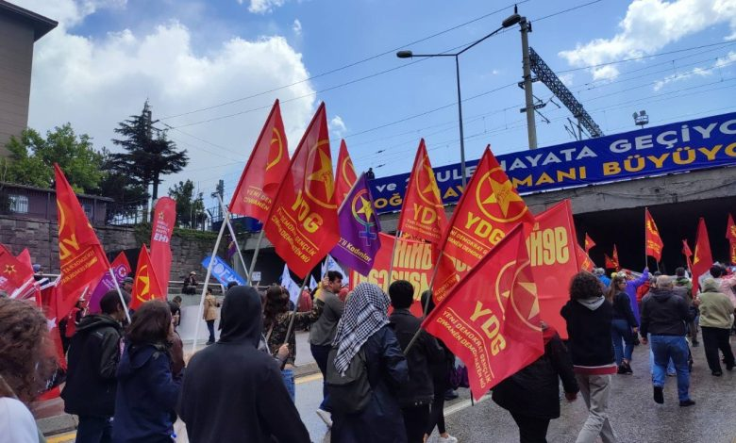
Participants marched to Tandoğan Square holding flags and banners. Banners reading ‘Long live May 1st,’ ‘The Istanbul Convention lives on,’ ‘This is just the beginning, the struggle continues,’ and ‘Justice, freedom’ were carried, while slogans such as ‘United we will win’ and ‘There is no salvation alone, either all together or none of us’ were frequently chanted.
After the processions reached Tandoğan Square, the rally programme began. Speaking on behalf of the organising committee, KESK member Mehmet Aydoğan said, ‘As the crises of the capitalist, imperialist system deepen, wars are intensifying. In Palestine, Ukraine and Syria, people are left to face destruction, hunger and death. While imperialist powers are making new plans for division, the ruling regime in Turkey is joining this war caravan in pursuit of its own interests. Basic expenditures have reached record levels; while resources are being transferred to multinational companies, the people are being condemned to poverty, unemployment and insecurity. As workers of this country, we too are being left to face hunger and poverty.’
Following the speeches by union representatives, artist Erdal Güney gave a concert.
The people of Izmir took to the streets for May 1st: This system will change!
Workers, students, and labourers gathered in Gündoğdu Square in Izmir on May 1st to protest the economic crisis, injustice, and oppression.
May 1st, International Unity, Struggle and Solidarity Day, was celebrated in Izmir with an enthusiastic rally attended by thousands of workers, young people, women and revolutionaries. Crowds gathered at different points in the city from early morning and marched in processions to Gündoğdu Square.
The rally, organised by KESK, DİSK, Türk-İş, the Izmir Bar Association, the Turkish Medical Association and TMMOB, was attended by Partizan, YDG, SMF, ESP, DEM Party, EMEP, TİP, SOL Party and many other democratic mass organisations. By 1 p.m., when the rally began, the square was completely filled.
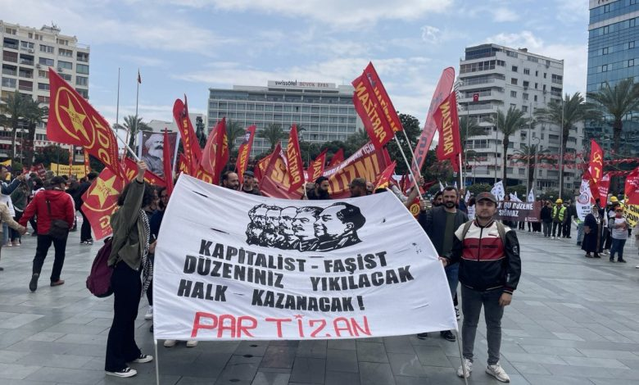
At 11:00 a.m., Partizan and Yeni Demokrat Gençlik (YDG) gathered at Cumhuriyet Square and marched to the rally site carrying a banner reading, ‘Your capitalist-fascist order will be destroyed! The people will win!’
’No justice will come from this broken system"
In a joint statement read by the May 1st Committee, the economic crisis, rising living costs, and repressive measures were criticised. The statement said, ‘Due to the Turkish Statistical Institute's (TÜİK) false data and the inflation spiral, workers, civil servants, and pensioners are being forced to live on the brink of starvation. In this system where the right to protest is violently suppressed, we are fighting because “justice cannot come from a broken system.”’
‘We are the resisters everywhere’
The statement sent greetings to workers, healthcare workers, public employees, and youth continuing their resistance in various regions from Kemalpaşa to Urfa, and from Çorum to Çatalca. ‘We are those condemned to retirement in the grave, we are those who defend secularism and life, we are those who resist the slaughter of nature and animals,’ the statement said, bringing together different struggle headings.
High school and university students drew attention to the lack of future and housing problems facing young people, while women and LGBT+ people raised their voices against male-state violence. The emphasis was placed on the fact that ‘the struggle of women is not separate from the struggle of LGBT+ people.’
The rally ended with a concert by artist İlkay Akkaya, who performed songs in Turkish and Kurdish. Gündoğdu Square echoed with halay dances, slogans and determination.
May Day excitement in Çanakkale
May Day, the day of unity, struggle and solidarity for the working class, was also celebrated with enthusiasm in Çanakkale.
The May Day celebrations in Çanakkale began with a march by a procession that gathered at the old Tuesday Market at 12:30 p.m. The crowd marched to Republic Square chanting slogans. They sang folk songs and danced halay. Speeches were made at the rally held there on behalf of trade unions and democratic mass organisations.
Members of Partizan, YDG, and YDK also participated in the march alongside HDK banners.
May 1st was celebrated with enthusiasm in various cities across Europe
May Day was celebrated across Europe with the spirit of international solidarity and resistance against fascism, capitalism, and imperialist wars. From Germany to Austria, the streets were filled with enthusiastic marches of workers, migrants, and revolutionary organisations.
In European cities, May 1st was celebrated as the Day of Unity, Struggle and Solidarity, with the spirit of unity, struggle and solidarity of the working class. Revolutionary and labour organisations raised a common voice against fascism, capitalist exploitation and imperialist wars, celebrating May 1st with mass marches, rallies and festivals.
Germany
Hannover
A mass march was organised as part of May 1st celebrations. The march began at 9:30 a.m. in front of Freizeitheim Linden and was attended by many organisations. Throughout the march, slogans against fascism and capitalist exploitation were chanted. New Democratic Youth (YDG) and ATİK took part in the march with their banners and flags. Speeches were made in Turkish, Kurdish and German, and slogans were chanted. The speeches emphasised that the imperialist and capitalist system exploits the working class and that unjust wars, genocides and massacres continue in many regions, particularly in Palestine and Kurdistan. Partizan drew attention with a banner reading, ‘Remembering İbrahim Kaypakkaya is fighting.’
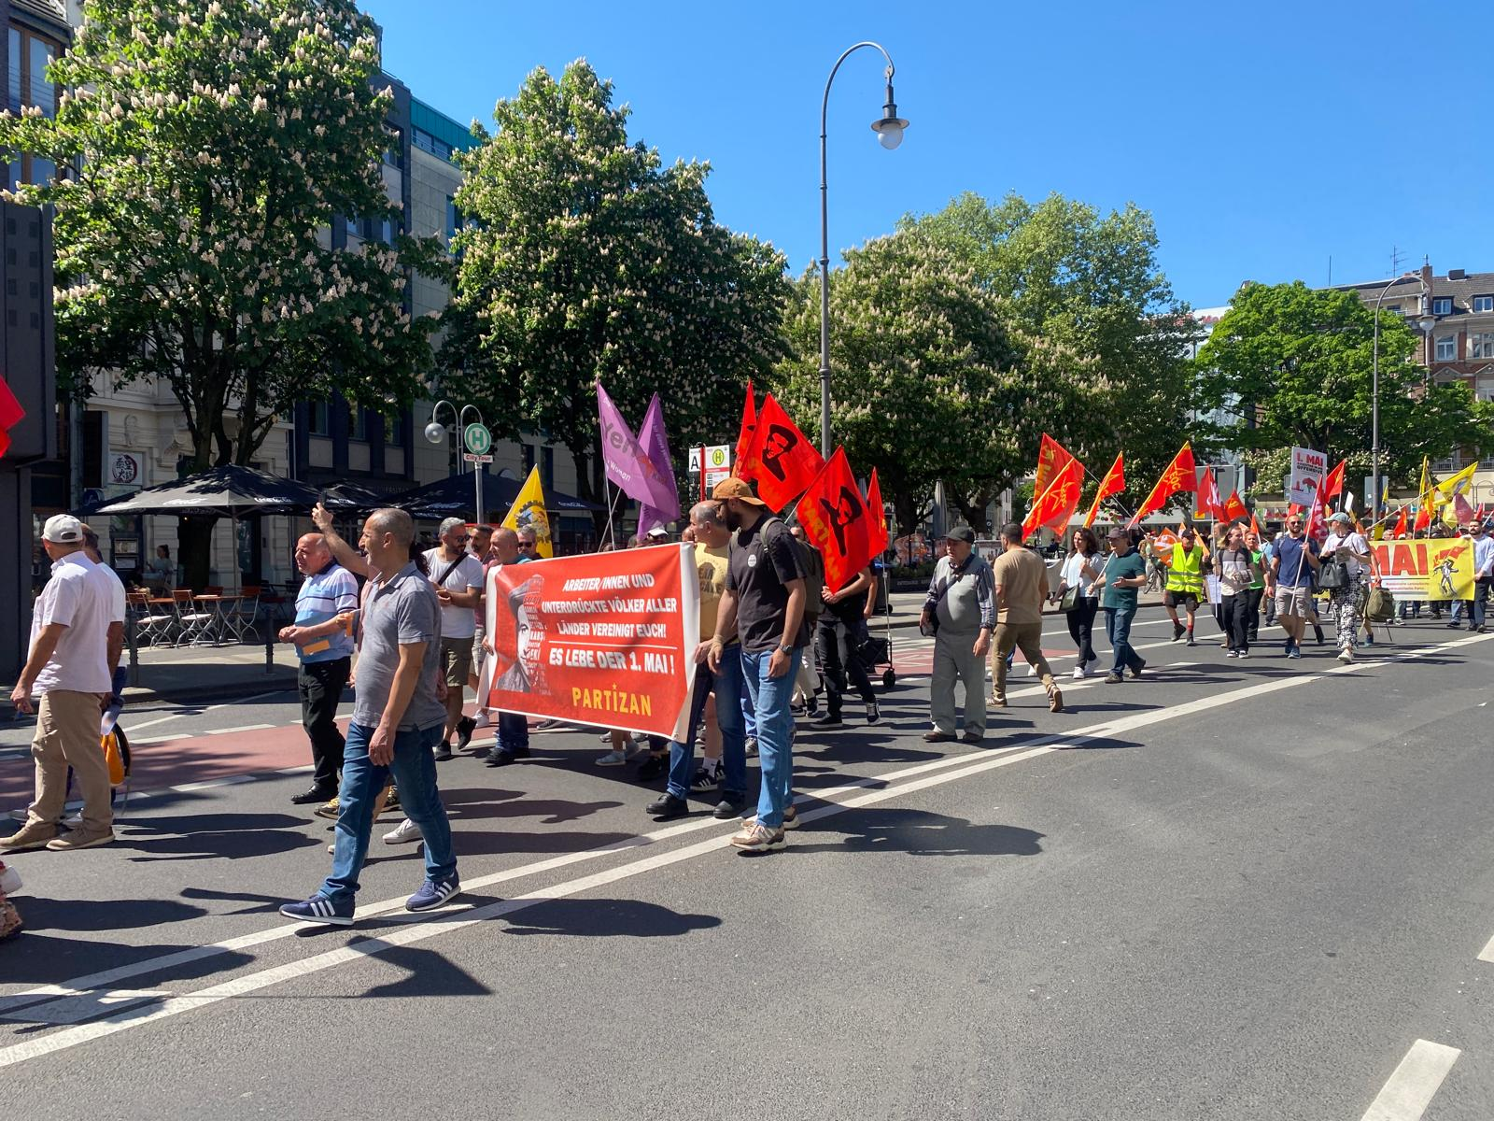
Cologne
Unions affiliated with the DGB, migrant and local organisations, and political parties gathered at Hans Böckler Platz Square at 12:00 PM and formed processions to march. Local and revolutionary organisations formed a joint bloc under the name ‘Red 1 May Platform.’ Partizan and Class Theory participated in a joint procession to commemorate İbrahim Kaypakkaya on the 52nd anniversary of his death. The march highlighted the dangers of imperialist war, militarisation policies, and the rising threat of fascism, calling for joint struggle and solidarity. Throughout the two-kilometre march route, emphasis was placed on poverty, layoffs, and the social issues caused by high inflation. People in the surrounding area showed interest and occasionally cheered in support during the march. The event ended with speeches and music performances at Heumarkt Square, the rally site.
Schwenningen
In accordance with the joint decision taken during the action alliance meetings that began weeks earlier, the crowd gathered at the Schwenningen train station at 10:45 a.m. and marched to the site of the DGB's May Day festival. At 11:00 a.m., Die Linkes Zentrum Schwenningen, ATİK, Yeni Kadın, ADHK and Verdi Sendika flags and banners with the slogan ‘international solidarity’ entered the DGB rally area behind a joint banner. Until 12:30 p.m., conversations were held with the crowd, and ATİK's May 1st statements and ATİF's bulletin opposing the new government's policies were distributed. After leaving the rally site at 12:30 p.m., the crowd gathered again at the Schwenningen train station.
At the rally held here, ATİF's May 1st statement was read in Turkish and German, followed by the May 1st statements of Die Linkes Zentrum Schwenningen and ADHK. Afterwards, a march towards the city centre began with slogans. Finally, the crowd gathered at the city centre and dispersed after a short speech, agreeing to meet again for future actions.
Stuttgart
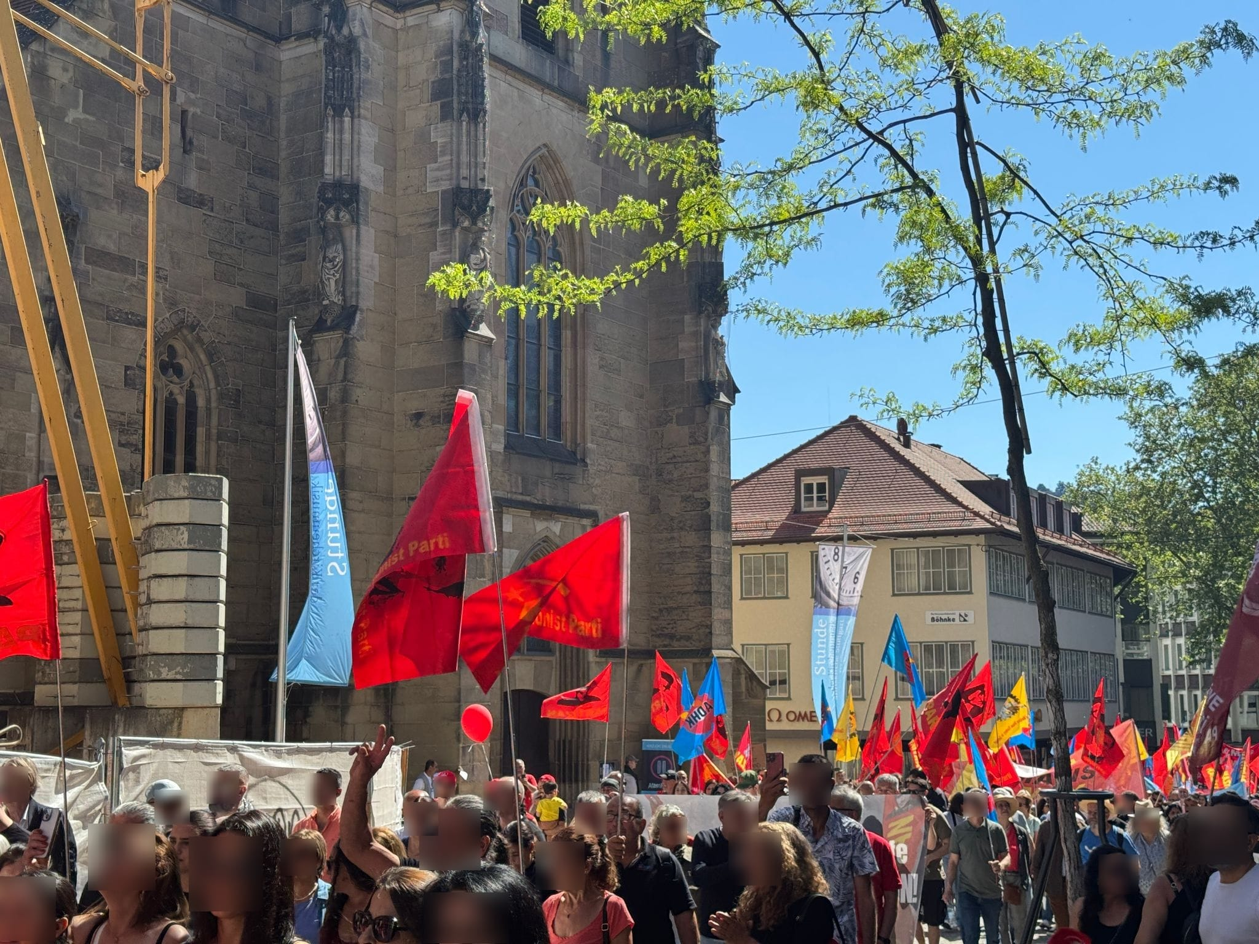
The event, which began at 10:00 a.m. at Marktplatz at the call of the trade unions, was also attended by Turkish and Kurdish organisations. ATİF, YDG and Yeni Kadın took part in the march organised jointly by ADGB and the Anti-Capitalist Block with a banner reading ‘Resist Fascism, Win the Future’. Throughout the march, slogans of international solidarity and resistance against fascism were frequently chanted. The highly enthusiastic march concluded at its starting point, Marktplatz.
After the march, the Stuttgart Tohum Cultural Association, affiliated with ATİF, organised a ‘May Day Celebration.’ The event featured folk songs, marches and poems, as well as speeches on the historical and current significance of May Day.
Duisburg
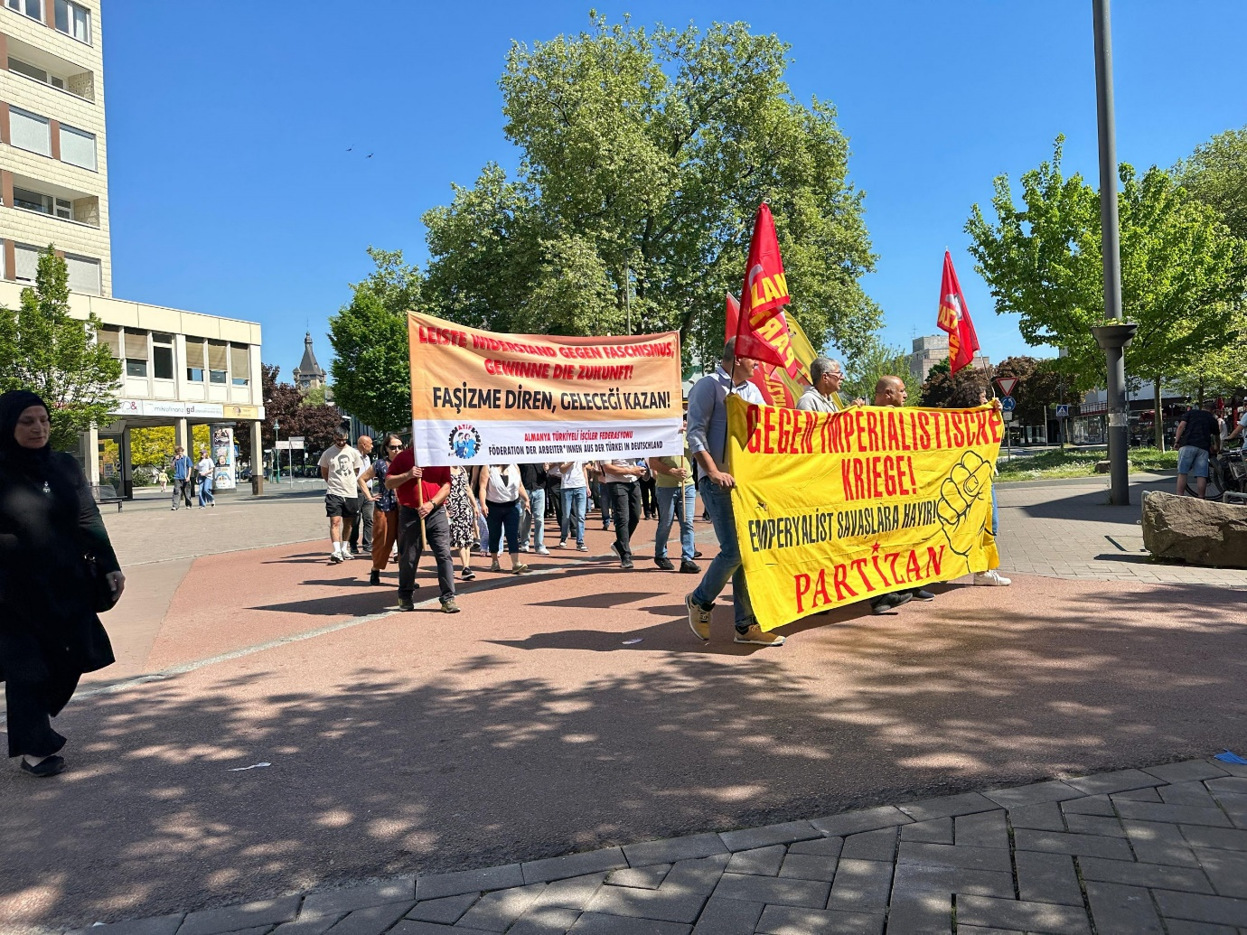
The event began at 11:00 AM with a gathering in front of the Hamborn District Court. Under the moderation of the MLPD, various trade unions, migrant and local organisations, and political parties delivered speeches. The crowd, accompanied by the musical programme of the group La Liberta, began the march at 12:00 PM.
The action was attended by IG Metal, DGB, DİDF, SPD, Die Linke, Verdi, Grüne, Marxloh Alevi Association, Sol Party, People's Unity, Democratic Kurdish Community Centre, Komkar, Palestine Freedom Committee, AWO, MLPD, RJ, MLKP, YS, Partizan, New Women, and YDG. Throughout the march, slogans such as ‘Israel is bombing, Germany is financing,’ ‘Freedom for Kurdistan,’ ‘Our leader Ibrahim Kaypakkaya,’ ‘Rebellion against fascism, the people's leader Partizan,’ and ‘No to imperialist wars’ were chanted.
Towards the end of the march, the police attacked the Palestinian contingent and attempted to arrest several people. The attack was thwarted by the crowd, which included members of YDG. The enthusiastic demonstration ended with a festival in Landschaftspark Nord.
Koblenz
The traditional May Day march in Koblenz was held again this year with large participation and enthusiasm. The crowd gathered at Reichensbergplatz at 11:00 a.m. at the call of the DGB trade union and began marching at 11:30 a.m.
In addition to trade unions, German political parties and democratic mass organisations also participated in the march. Turkish and Kurdish migrant workers also took their places in the procession. A banner prepared jointly by ATİF-Koblenz and OAT Koblenz (Anti-Fascist Union) attracted the attention of participants. Alongside a banner reading ‘Eure Kriege, unsere Krise!’ (Your wars, our crisis!), a tank model was used to protest militarism and imperialist war policies in Germany. At the end of the march, the tank model was symbolically destroyed. This protest action sent an effective message against war policies and was supported by the crowd with applause.
Austria
Vienna
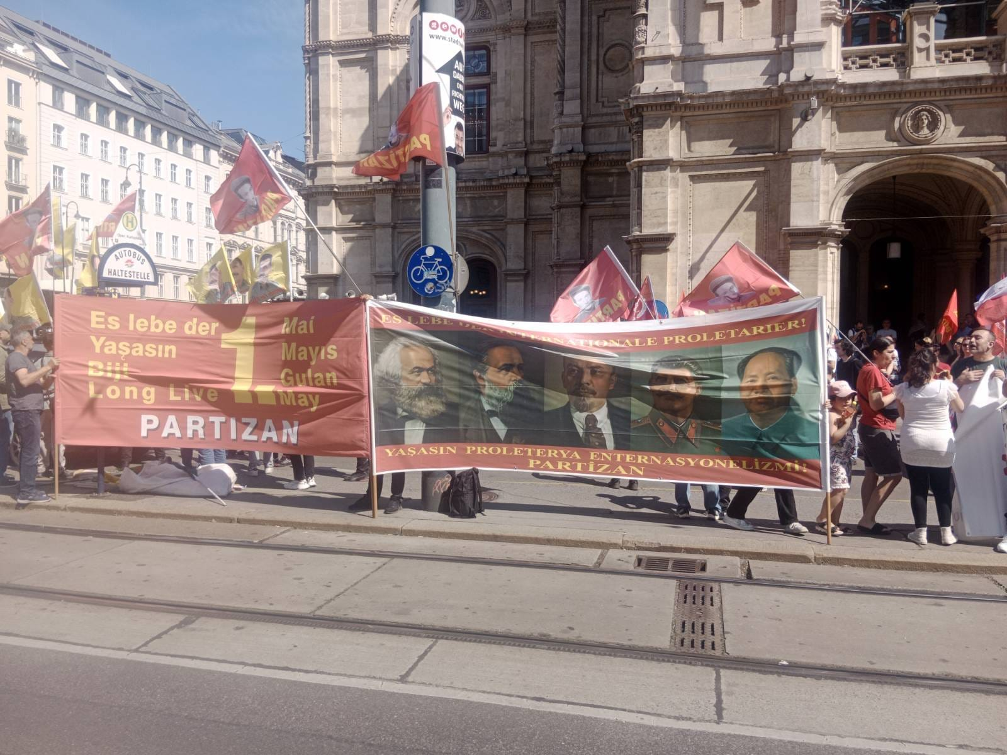
In Vienna, May 1st was celebrated with a large festival and march, as it is every year, with the participation of Austrians, Turks, Kurds, and Alevis. Early in the morning, preparations for the festival were completed in Viktoriapark, and participants gathered at Karlsplatz Opera at 11:00 a.m. The march included ADİF, Partizan, Palestinian, and Iranian revolutionary organisations.
Throughout the march, imperialist aggression, massacres in the Middle East and Kurdistan, and war policies were protested. After the march, participants arrived at the festival area, where various speeches were made. Here, halay dances were performed to music, and the event concluded at 7:00 PM.
Linz
As every year, celebrations were organised in Linz by the 1 May Action Committee. Speeches were made throughout the march, and the 1 May statements published by ATİK in Turkish and German were distributed. At the end of the march, joint speeches were made on behalf of ADİF and the Action Committee. The event concluded with halay dances and music.
Innsbruck
A mass May Day march was also held in Innsbruck. The crowd gathered in front of the governor's office at 11:30 a.m. and delivered opening speeches before the march began. ATİK and ADHK formed a joint procession and marched together. The ATİK statement was read out during the march and supported with slogans. The event was organised by democratic mass organisations and trade unions.
Bregenz
In Vorarlberg, a May Day march was held at the call of Austrian revolutionary organisations, the Kurdish Community Centre and the ATİK committee. After the march, celebrations continued at the Kurdish Community Centre with international anthems.
May Day event by the Martyr Nubar Ozanyan Armenian Brigade
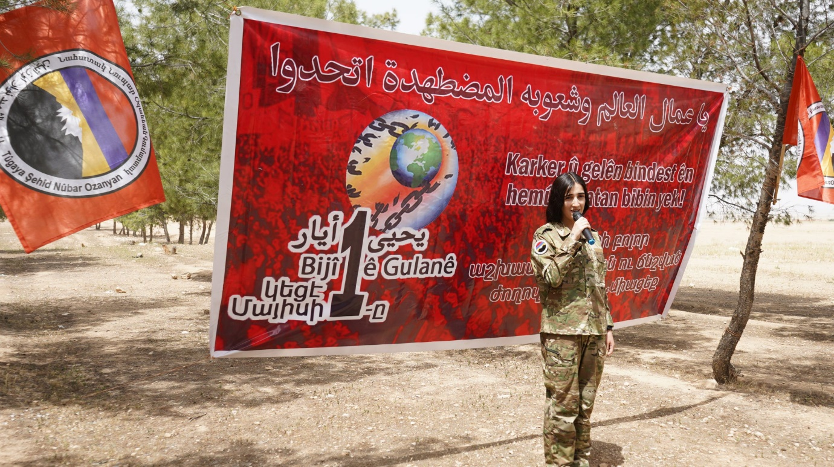
The Martyr Nubar Ozanyan Armenian Brigade greeted May Day with the slogan ‘Workers and peoples of the world, unite!’ and drew attention to international solidarity and resistance at the event.
The Martyr Nubar Ozanyan Armenian Brigade organised an event on May 1st, Labour and Solidarity Day, with the slogan ‘Workers and oppressed peoples of the world, unite!’ The event, which was held with great enthusiasm, began at 11:00 a.m.
The programme began with a minute's silence in memory of those who lost their lives in the struggle for democracy and freedom, especially the martyrs of May 1st. In the opening speech, it was stated, ‘Today is May 1st; today, all workers and labourers are taking to the streets. May 1st is not just a day in history; it is a day when the oppressed and workers around the world are united as one.’
After the opening, a speech was delivered on behalf of the Brigade Command. Beginning with the words, ‘Workers of the world, unite,’ the speech included a brief assessment of the international working class struggle. The speech concluded with the following words: ‘May 1st is a great day, May 1st is a blessed day. There is much to learn from May 1st, and we will do so. As the Brigade Command, I celebrate the 1 May Labour and Solidarity Day of our fighters. I wish success in our struggle. Long live 1 May!’
The event continued with collective games. The programme concluded with the Brigade fighters chanting ‘Long live 1 May’ in Armenian, Arabic, and Kurdish.
