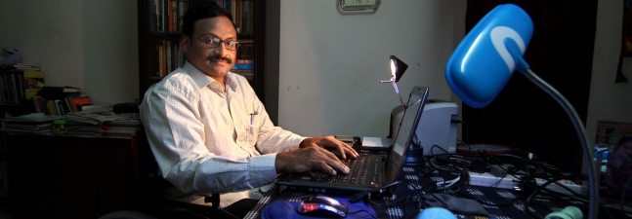

India: Revolutionary intellectual-activist GN Saibaba abducted by police
May 10, 2014

Rise! Resist! Liberate!
Revolutionary Democratic Front [RDF]

Condemn the dastardly clandestine abduction of Dr. GN Saibaba, Joint-Secretary of RDF, by the Maharashtra Police!
Today, the 9th of May, plain-clothed personnel of the Maharashtra Police abducted Dr. GN Saibaba while he was returning home from Daulat Ram College in Delhi University after examination duty. Dr. Saibaba, who suffers from 90% disability and is on a wheelchair, was blindfolded and pushed into a vehicle. After this secretive arrest of Dr Saibaba from within the university premises, it is believed he is being taken to Gadchiroli in Maharashtra by flight. None of his family members were informed and after repeated efforts to contact him, the driver of his vehicle informed the family of his abduction. This stealthy and dastardly abduction of a university professor smacks of the desperation of the Maharashtra police and violates the basic human right of an upstanding, democratic voice in this country. This abduction, it is believed, to be with regards to a fabricated case filed by the Maharashtra police that subsequently conducted a raid and an interrogation at Dr. Saibaba’s residence on the 12th of September and 7th of January respectively. During both the raid and the interrogation, Dr. Saibaba and his family extended their full cooperation with the police and intelligence forces. This abduction by Maharashtra Police reflects the extent to which the police can stoop to rake up false charges in fabricated cases and implicate voices that speak up for the democratic rights of people.
President of RDF in Uttarakhand, Jeevan Chandra, was similarly picked up on 5th of May in Uttarakhand. The charges against him were that of having connections with the Maoists and calling for the boycott of the elections. RDF strongly condemns the abduction of Dr. Saibaba and the abduction and arrest of Jeevan Chandra by the police force.
RDF calls for a protest demonstration at Maharashtra Sadan on 10th of May (Saturday) at 11 am.
We appeal to revolutionary and democratic individuals and organizations to join in large numbers.
PROTEST DEMONSTRATION against clandestine abduction of Dr. GN Saibaba by Maharashtra Police at Maharashtra Sadan, Kasturba Gandhi Marg, on 10th May (SATURDAY) at 11 am.
Varavara Rao, President, RDF (09676541715) Rajkishore, General Secretary, RDF (09717583539)

