Mr. Chidambaram, How can
you do this to your own people?

November 25, 2009 Moonchasing.wordpress.com

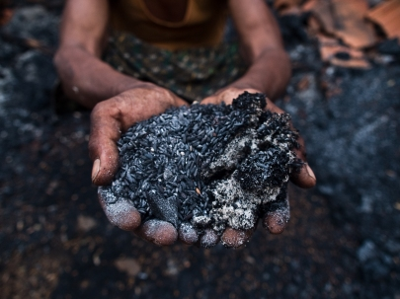

Rice to ash: Sodi Idma with the remnants of his produce. Like most
of the villagers of Tatemargu, he lost around twenty-thirty quintals
of rice to the fire that ravaged his home, when his village was raided
by the security forces on the 9th of November, 2009.

On the 9th of November, 2009, security forces had raided the village of Tatemargu of Konta Block, Dantewada district of Chhattisgarh.
Once news of the approaching forces reached the village, all the villagers ran into the jungle with what they could carry. They scattered in all directions and only returned once they got news that the security forces had left their village. They returned to find burning homes and distraught villagers who were taken into custody by the security forces, and then released in the village itself. They told the rest of the villagers their stories and identified those who was taken away. Many took their time to return from the jungle. And only once all the villagers were back and reunited, did they begin to piece together what had happened – and who was missing.
Eventually, the villagers received news from villages closer to Kistaram, some fourteen kilometers away, that seven people were killed near the police station.
One of them was Madkam Idma from Tatemargu who ran with most of the villagers when news of the approaching forces reached them. However, he turned back to his home to collect some food to survive in the jungle. He was inevitably captured with some 14 other villagers, and was one of four of his village, who were taken towards Kistaram police station, where they were reportedly shot dead on the 10th of November.
Two villagers from Doghpar, who were working in the fields, were apprehended prior to the raid on Tatemargu, and were also shot dead.
Security forces had also raided the village of Pallodi, some 12 kilometres from Tatemargu, where they reportedly burnt some 30 homes and apprehended Madvi Joga, who was also shot dead as a Naxalite, taking the total dead to seven.
‘With so much difficulty I bring my children up, and this is what happens.’ Says Madkam Jogi, mother of the young Madkam Idma, who was described as a shy reclusive young man of twenty. She also had to clear the rubble from her home with her remaining son, who is around fourteen years old. She has around 10 acres of land and lost around 20 quintal or rice in the fire that consumed her home.
Eventually, a few of the villagers decided to go to Kistaram police station to recover the bodies. At the police station, they were told that the bodies were taken away. They returned, dejected and confused, and would eventually begin to assess all the damage to their homes and their produce.
Some villagers would also begin to rebuild their homes with whatever they could find. However, most of them are still afraid to return to their homes out of fear that the security forces would return. They now live in the fields or in the jungle.
At Tatemargu, there were around sixty burnt homes disproportionately damaged. Some were raised to the ground, and others were partially saved from the fire by the villagers. Some were made of brick and cement and others were smaller homes made of mud and hay. Some homes survived in their entirety with all their produce while others were burnt to the ground with everything in them – along with bicycles, clothes, money, radios and even the bell-gaadis.
One villager, Kalmu Soma, who has around 30 acres of land, lost around 60 quintals of rice, around 20 quintals of Mahua, a solar plate and its battery, a motorcycle and his home. Another, Vanjam Mungdroo, who has around 3 acres of land, lost around 3 quintals of rice, 1 quintal of Mahua, 2 goats, a chicken and his home.
Vanjam Idma lost 10 quintals of rice, 2 quintals of Mahua, 30 kilograms of imli and both of his homes.
Sodi Sukda, lost around 40 quintals of rice, 7 quintals of Mahua and a house of cement and brick that took him five years to build.
Hoongi Madkam, age forty, managed to save her house and her produce but lost her husband, Oonga Madkam.
Sukda Raja, age 50, lost his brother, Dodhi Raja.
‘These kinds of things happen in war’ – is what the visiting Naxalites would tell the villagers.
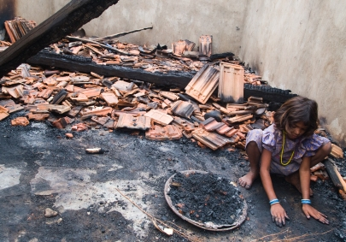

Devi Idma, helping to clear her father’s home of ash and debris, after
the security forces attacked her village on the 9th of November, 2009.

The Combing Operation

On the day of the raid, which started around 11 in the morning, a few villagers, were apprehended by the security forces and then eventually released. They were kept in separate groups under different guard. Five were kept in one group, and ten in another. The two villagers from Doghpar were kept in the group of five.
According to the ones who were released, the security forces numbered to more than five hundred and they would begin to capture the goats, the chickens and the ducks of the village of Tatemargu and start cooking them in separate areas. There is no exact estimate on the number of animals eaten by the security forces but each home out of the 27 interviewed, claims to have lost an average of around two-three chickens. One villager claimed that six of his pigeons were missing. There is a rough estimate that around ten-fifteen goats and five-ten ducks were eaten.
The police had also taken the group of 10 villagers to a monolith painted in red that had been built to commemorate a fallen Dalam member Chutey Khoja, who was shot dead in Bijapur last year. He had apparently joined the Dalam as a ten-year old, claiming to be an orphan. In fact, he had joined the Dalam after an argument with his mother, who now lives alone at Tatemargu.
Eventually the police started to question the villagers about the Monolith. Who built it? Who is this person? Why is Comrade Chutey Amar Rahe written on it? When the villagers feigned ignorance out of fear, they were beaten. They eventually confessed that the Naxalites had asked them to build it and the police would begin to chip away at its base, hoping to destroy it. However, the structure remained – the security forces would only rip off the sickle and hammer that stood on the crest of the monument.
Around the same time, a few of the Special Police Officers (SPOs) would begin to misbehave with the six women that were in their custody. They would deliberately start cutting the hair of eighteen-year-old Jogi Madvi with a knife. According to the witnesses, who were eventually set free, a senior ‘adhikari’ in uniform, who spoke Hindi came to her rescue.
‘How can you do this to your own people?’ said the officer who apparently snatched the knife from the perpetrator and threw it away. The women weren’t mistreated after that.
The same officer also refused the food that was made from the livestock of Tatemargu..
The security forces left the village of Tatemargu around five in the evening and camped across the mountain in the jungle with the four villagers from Tatemargu and two from Doghpar. The next day, they entered Pallodi, where they allegedly burnt down 30 homes, and captured one villager.
Somewhere, on the way, all seven of them were shot dead.
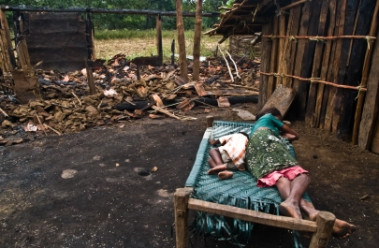

Devi Mangdroo sleeping next to her son and the remnants of her
burnt home, as well as her newest settlement. She lost around three
quintals of rice in the fire that was started by the security forces.

Tatemargu, a Naxalite Village?

Most of the Muria villagers from Sukma first settled at Tatemargu around fifty years ago. They brought their techniques of cultivation from Jagdalpur and the abundance of resources made Tatemargu an ideal location for cultivation. They had an ample supply of water, and they have never used pesticides on their crops. Reportedly, agriculture has never failed in their village, even though cultivation has all but ceased in the majority of Dantewada and Bijapur districts of Chhattisgarh – ever since the inception of the Salwa Judum.
At Tatemargu, long before the Naxalites came, a villager was beaten or chastised by a forest official for cutting too many trees for cultivating land, or for some other discretion. ‘To live here, you must bear a few beatings.’ – was what the old women of Tatemargu would tell their children.
Eventually, the village would begin to thrive. The villagers started to build large homes with bricks and cement. Some of them would spend around five years building their homes. Many families had produced an average of around 30 quintals of rice per season. Two villagers, one Deva Kovasi, claims that a Special Police Officer (SPO) stole some Rs.30,000 from him when he was trying to escape the raid; the other, Oonga Kanmu, claims that he lost Rs.15,000, along with some jewels from his home.
Some families had around 30 acres of land, some around 100 cattle. There are currently around 800 people and a majority of the families have over 10 acres of land, yet there are still many poorer Muria who have only five to three acres. Most of the homes have goats, cattle, chickens and even some ducks. The village of Tatemargu, is unofficially described as the number one village at Konta block.
The Naxalites had imposed prohibition – restricting the intake of liquor rather than completely banning it. They also ensured that everyone worked on everyone’s land. Those who drank too much and did little work, weren’t allowed more than three acres.
The government opened an angaanbadi centre. There were 10 cases of polio in the village before the angaanbadi services started, but as anti-polio vaccines were made available through the angaanbadi service, there have been no cases of polio. However, angaanbadi services have been discontinued since the Salwa Judum started. Healthcare is now minimal. Only the leftover medicines for sore throats, fevers and headaches remain. Most have expired. If people are capable of traveling to a city for healthcare, they often choose to. If they are incapable of traveling and afflicted with a severe illness, they often just die.
In fact, Tatemargu in Konta Block has been left completely untouched by government influence ever since the Salwa Judum. One handpump was installed during Ajit Jogi’s last tenure and it has stopped working over a year ago. There is no one to repair it.
There has never been any electricity at Tatemargu. Two villagers had two solar panels which were wrecked by the security forces. They even vandalized whatever remained of the angaanbadi centre and the school.

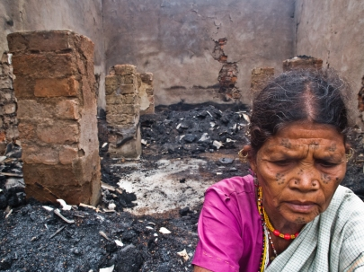
Sodi Sukda sitting before the burnt produce from her home. She
lost around forty quintals of rice – some seven years of produce.
Text and photographs by Javed Iqbal/For The New Indian Express

In 2005, the only remaining teacher was given a choice to teach in one of the Salwa Judum camps near Konta, or to discontinue his service. He has around twenty acres of land and more than a hundred cattle at Tatemargu, his home – he claims that he can produce around 30 quintal of rice, and 20 kilograms of ghee a year – why should he be a teacher in some Salwa Judum camp where he and his family would have nothing? As it is, his family grew up in Tatemargu and refused to budge, and he wasn’t ready to abandon them. Is this what makes me a Naxalite? Is this why I deserve to die?

Yet families were still split apart. Many families of Tatemargu have relations at Konta or Sukma, living in Salwa Judum camps. Quite a few of the villagers of Tatemargu keep that fact a secret for fear of retribution, or incurring the wrath of the Maoists. They seldom meet one another and only manage to do so clandestinely. When the villagers of Tatemargu travel, which they seldom do, they always claim to be from some other village.
Their markets have also shifted – they have to sell their produce to middlemen from Andhra Pradesh, for a price of Rs.600-Rs.700 per quintal for rice, or to Kistaram market, for Rs.990 per quintal. They barely sell their wares at Kistaram for fear of being apprehended, or branded off as ‘Naxals’. This market situation also led to the hoarding of rice. Additionally, the hoarding is also an indication of a man’s wealth – the more rice you have, the richer you are.
This has been their situation since the Salwa Judum started.
‘When Muria kill Muria, who benefits?’ Asks Poodiyan Lakhma of Tatemargu, regarding the Salwa Judum. He was in Andhra Pradesh when he got news of the attack on his village by security forces. The news was bittersweet – while his three children and his young wife managed to escape unhurt, his home was burnt to the ground. He lost two quintals of rice, one quintal of Mahua, forty kilograms of corn and 20 kilograms of salt. He has only three acres of land and is one of the poorer inhabitants of Tatemargu.

