COMMITTEE FOR THE RELEASE OF POLITICAL PRISONERS
185/3, FOURTH FLOOR, ZAKIR NAGAR, NEW DELHI
CONDEMN THE ARREST OF GOUR CHAKRAVARTY,
THE WEST BENGAL STATE SPOKESPERSON OF CPI (MAOIST)!
RELEASE HIM UNCONDITIONALLY!
The Committee for the Release of Political Prisoners (CRPP) strongly condemns the arrest and media trial of Gour Chakravarty, the West Bengal State Spokesperson of the CPI (Maoist).
This is a complete volte face of the CPI (M) led government which had continuously insisted that they would deal with the Maoists politically. In fact it shows beyond doubt that the issues raised by the Maoists and the militant struggles of the Adivasis of Lalgarh have become a real problem for the CPM-led government in West Bengal. The only way that this government can deal with the issues of life and death for the toiling masses, pertaining to the four dreaded Ds—Displacement, Destruction, Destitution and Death—are through the baton and barrels of the police and paramilitary. Otherwise any people oriented government would have first listened to the just demands of the Adivasis of Lalgarh. The right to dissent against the policies of the State is a constitutionally guaranteed right. And when the people of Lalgarh have protested against the policies of the government which they understood would result in their peril, the political and administrative response of the government of West Bengal was through ruthless military action and a high voltage media blitzkrieg demonising the people of Lalgarh ably supported by the Central Government under Manmohan Singh and home minister Chidambaram.
Anyone who is closely observing West Bengal politics particularly since Singur and Nandigram struggles of the people can recall that Gour Chakravarty stood as a spokesperson of the CPI (Maoist) of West Bengal responding to the challenges thrown by Buddhadeb Battacharjee, the Chief Minister and CPI (M) for an open political debate on issues Maoists differ with the ruling party in the state. But the Chief Minister instead of engaging in a political debate with Gour Chakravarty being the political representative of the CPI (Maoist), put him behind the bars. Therefore, the basis for the arrest of Gour Chakravarty is intensely political. This shows that the Chief Minister and his ruling party did not want to answer questions raised by the Maoist spokesperson regarding the people’s issues entailing Singur, Nandigram and now Lalgarh. Instead they resorted to the brutal suppression of the voices of the people using military might and draconian laws like the newly promulgated CLAA by the central government. Ironically, while Buddhadeb Bhattacharjee was busy banning the CPI(Maoist) his own party was opposing the same as he went about the same law to arrest, incarcerate, and silence the incessant and flowing voice of Gour Chakravarty.
Gour Chakravarty as the spokesperson of the CPI (Maoist) had upheld the right to dissent of the Adivasis of Lalgarh against the World Bank, imperialist backed up anti-people policies of the West Bengal government. Further he had openly exhorted the people that merely fighting against the West Bengal government would not suffice as he was convinced that the fundamental problem was related to the exploitative, predatory class character of the Indian State. This conviction had made him exhort the people to do away with this parasitic apparatus of the Indian state.
Though the Constitution of India calls itself a democracy with the right to freedom of expression and association, the governments of West Bengal and the one at the centre would dread such a scenario where the people have the courage and conviction to stand against the policies of the government.
Gour Chakravarty had tried to measure the possibilities of the human face that the Congress government at the centre and the CPI (M) government in West Bengal were pretending to project before the people. He was only trying to push the limits of stability that these governments were promising the people before and after the parliamentary elections. His crime—he insisted that there cannot be any stability without the just interests of the toiling masses being served. Without putting an end to all forms of exploitation; humiliation; mistreatment; discrimination. All these ideals of Gour Chakravarty have become a ‘law and order’ question for the CPM-led government in West Bengal.
This also brings to the fore that the CPM-led government despite all its pretensions is no less different from a Congress or BJP government while addressing the burning issues of the common masses. To address sincerely the issues that are dear to the masses of the people one need to have the political will to openly defy the policies of the World Bank and imperialism.
Gour Chakravarty being the spokesperson of the West Bengal CPI (Maoist) has challenged the CPM-led government to be one of, by and for the Will of the masses of the people. He is the conscience of the toiling masses. He cannot be behind the bars. We demand his unconditional release.

27.06.09
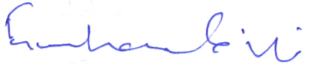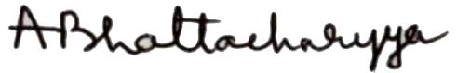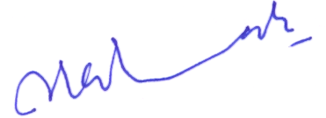
Gurcharan Singh Amit Bhattacharyya SAR Geelani
President Secretary General Vice President

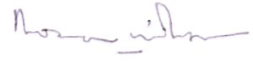
Rona Wilson
Secretary, Public Relations

