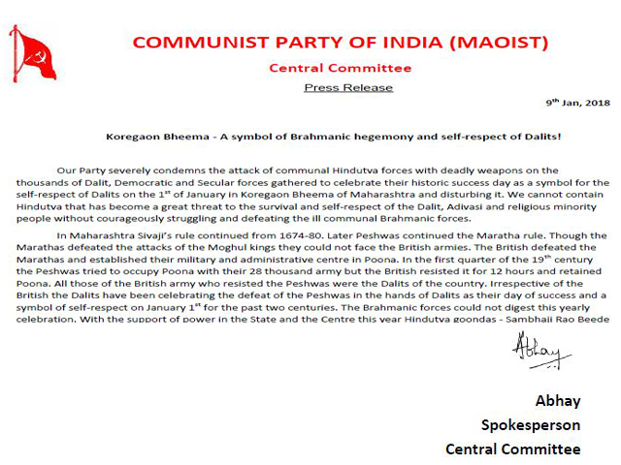
Our Party severely condemns the attack of communal Hindutva forces with deadly weapons on the thousands of Dalit, Democratic and Secular forces gathered to celebrate their historic success day as a symbol for the self-respect of Dalits on the 1st of January in Koregaon Bheema of Maharashtra and disturbing it. We cannot contain Hindutva that has become a great threat to the survival and self-respect of the Dalit, Adivasi and religious minority people without courageously struggling and defeating the ill communal Brahmanic forces.

In Maharashtra Sivajiʹs rule continued from 1674-80. Later Peshwas continued the Maratha rule. Though the Marathas defeated the attacks of the Moghul kings they could not face the British armies. The British defeated the Marathas and established their military and administrative centre in Poona. In the first quarter of the 19th century the Peshwas tried to occupy Poona with their 28 thousand army but the British resisted it for 12 hours and retained Poona. All those of the British army who resisted the Peshwas were the Dalits of the country. Irrespective of the British the Dalits have been celebrating the defeat of the Peshwas in the hands of Dalits as their day of success and a symbol of self-respect on January 1" for the past two centuries. The Brahmanic forces could not digest this yearly celebration. With the support of power in the State and the Centre this year Hindutva goondas - Sambhaji Rao Beede of Siv Prathishtan and Milind Ekbote of Hindu Ektha Manch led their gangs and attacked the Dalits and their supporters with deadly weapons in Koregaon Bheema on the 1" of January, 2018. Scores of saffron terrorist forces blasted cooker bombs and created terror in the people in and around Koregaon. A Dalit youth lost his life and many were injured in these attacks. The leaders of the Dalit Organisations informed the government and the police much before about the celebrations but they did not take up proper security measures to encourage the attacks of the Hindutva goondas. The government and the police encouraged the saffron terrorist goondas only to see that the Dalits do not try to celebrate such self-respect success days. In fact all this happened according to a plan. The gangs of Sambhaji and Milind only implemented the joint ill scheme of the Central and the state governments, their intelligence units and the Sangh forces. Our Party appeals to the Dalit, Adivasi, people of minorities, democratic and secular forces all over the country to expose the ill tactics of the Chief Minister of Maharashtra Devendra Fadnavees.

More than a hundred Dalit, Democratic, Secular, Progressive, Rational and Revolutionary forces called for Maharashtra Bandh on the 3" of January to condemn the attacks on the Dalits of Koregaon Bheema. People across the country felt raged with the Hindutva attacks. They took up militant actions against the government in many places. It is a sad thing that Prakash Ambedkar and the Bhaaratheeya Republican Party that was one of the main organisations that called for the Bandh withdrew it. No one shall support this withdrawal that undermines the actions of the saffron terrorists who fired bombs and guns, broke heads with sticks, attacked men and women indiscriminately, complacent with the assurances of the Hindutva leaders and worried with the militant deeds of the people in protest.

The goondas Sambhaji Beede and Milind Limbodi who took up attacks on the Dalits in Koregaon Bheema are still moving around freely. We can understand their close association with the peopleʹs main servantʹ Modi from the election propaganda rallies in 2014. Our Party also severely condemns the arrest and foisting of false cases by the Maharashtra police in Mumbai on the young leader of Gujarat people lignesh Mevani and the student leader of JNU Umar Khalid who highlighted the self-respect of the Dalits.

Whatever Hindutva Modi speaks about the uplifting of the dalits and highlighting the supporter of the oppressed people Ambedkar with his ill tactics is a part of the Hindutva conspiracy and nothing else. Let us raise our voice that Modi, a greater Manu who says that everyone must do their dutyʹ in Brahmanic Chathurvarna system, caste order and untouchability like the Bhagavadgeetha does not have the moral right to praise Ambedkar and that we shall never tolerate a single word he speaks ill of Dalits. Our Party appeals to the oppressed people to fight united and organized against the aggressions of the Hindutva forces ruling with blood stains, starting from Rohith Vemula to the Dalit youth in Koregaon Bheema. It is time for the democratic, secular and progressive forces to expose the deception of the Brahmanic opportunist politics and support peopleʹs struggles. All that Modi speaks about the construction of Nava Bharath irrespective of religion and caste is nothing but fake talk. Our Party makes it clear that no Nava Bharath can be established without the formation of a New Democratic Society that does not give way for the difficulties and miseries of the people, eliminates exploitation and sees that there is no chance for discriminations of caste, religion and gender.

Abhay
Spokesperson
Central Committee
CPI (Maoist)
Keywords : Koregaon Bheema, maharashtra, pune, dalit
(2018-02-04 21:13:42)

