
COMMUNIST PARTY OF INDIA (MAOIST)
DANDAKARANYA SPECIAL ZONAL COMMITTEE
Press Release
19 June , 2015
The closure of three thousand schools and ashrams by the CG government is a symbol of the economic and academic bankruptcy and its anti people character
The Chathisgarh government started the present academic year of 2015-16 with the closure of three thousand schools and ashrams (residential schools). It closed all these ashrams in the name of lack of admission. The teachers in these schools were transferred to the near by schools. Most of these are primary and middle schools and happen to be in the adivasi area, especially in Bastar division. This not only reveals the anti people and anti adivasi character and history of the BJP government but also exposes its economic and academic bankruptcy.
Of late, due to the shameful conditions of the imperialist financial institutions like the International Monetary Fund and the World Bank, the government adopted anti people policy and brought down people's welfare schemes. Education is being more and more privatized. This is a step towards the conspiracy to deprive the poor adivasis, dalits and backward sections of education and development.
In the name of bringing down the expenditure on establishment, the appointment of teachers and the third and fourth class government employees were withheld long back. In the name of appointment of siksha karmi, contract teachers, daily wage, and casual employees and on contract, temporary appointments are being made with low wages. Now thousands of ashrams in the state were closed. The adivasi area that has been facing the problems of lack of schools, teachers, and illiteracy has now been much deprived of children's education. The appointment in the vacancies of tens of thousands of teachers was permanently brought to a stop. The unemployed in the backward adivasi areas have been deprived of employment. Due to the financial bankruptcy of the CG government it implemented cuts in providing infrastructure like library, laboratory, uniforms, note books, and text books, mid day meals, recruitment of new teachers, their wages and other facilities.
The actual meaning of the constant fake propaganda in the TV and Radio 'bachho, padho-likho, aage bado' (children, read-write, go forward) and that Maoists are against tribals' education has been nakedly revealed to the people. For children, especially girls who cannot afford to go to school even in their own villages; it would be almost difficult to go to schools far away. The inevitable situation in which the girls and boys of the family are forced to do domestic work, labor, and farming is itself a curse. This is depriving them of education. Instead of bettering the situation of such kind of families and educating the children, the government is closing the ashrams in the name of lack of admission. This is nothing but worse conspiratorial and negligent attitude of the government towards the education of the oppressed sections. This would affect women's literacy and the literacy of adivasi women would fall under the dark. Narendra Modi's reiterating slogan, 'beti bachao, beti padhao' (meaning 'protect girls, educate girls') is clearly revealed to the people. These kinds of slogans are given only to mislead and mystify the people. On one hand thousands of ashrams are being closed and on the other the Minister of education of Chathisgarh, Kedar Kashyap announces that in the present academic year six and a half lakhs of children would join the ashrams. This is not only ridiculous but also misgiving. Backward classes, dalits and adivsis, especially the women in these sections are deprived of education which proves the anti adivasi, anti education and anti development.
The Raman singh government that is depriving the backward sections, Dalits, adivasis of education is in fact anti development. The real meaning of Raman singh's development is that of the domestic and foreign corporate giants and is giving away the jal jungle and zameen of the people to them. The meaning of development is the absolute deprivation of the poor, backward, dalits and adivasis of basic amenities like food, shelter, clothing, education, health, drinking water etc. Raman Singh is afraid that if the adivasis are educated, they would become elite and would raise their voice much more strongly against their exploitation and repression and that they would intensify armed struggle for their genuine development and self rule.
Many of the schools in Bastar Division even now happen to be the shelters of the police and para military forces. In spite of the direction of the Supreme Court of the country this situation exists as and how the forces wish. On the other side the schools that are being run by the Revolutionary Janathana Sarkar(RPC) that has been formed under the leadership of our Party are being targeted by the armed forces of the government. The dozens of schools of the janathana sarkar (people's government) that are being run in Narayanapur, Kanker, Bastar, Bijapur, Dantewada and Sukma districts were attacked and the notebooks, textbooks, clothes and other such essential articles have been burnt. This clearly reveals the fakeness of the Raman singh government regarding the education of the adivasis.
Our party calls upon all the students, teachers, parents and guardians, progressive and democratic intellectuals, human rights organisations, adivasi and non adivasi social organisations to strongly protest the anti education policy of the Chathisgarh government and to take up programs to demand the withdrawal of the decision of closing the ashrams. We call upon the people and teachers of the affected villages to come forward and demand the retaining of the ashrams in their original places.

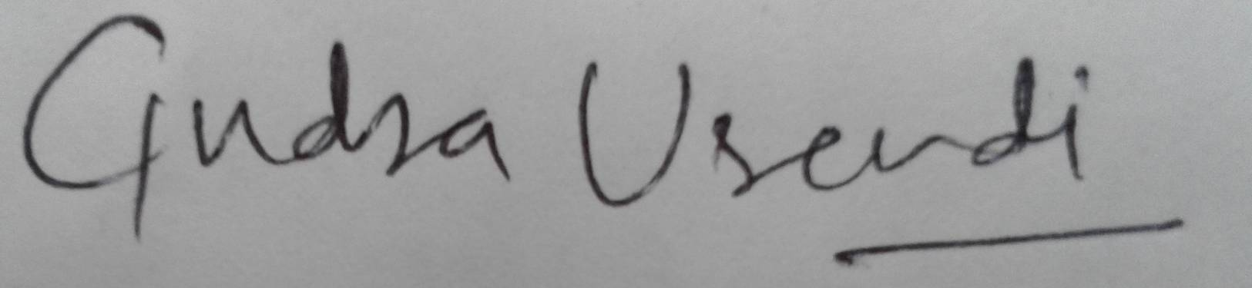
(Gudsa Usendi)
Spokesperson,
Dandakaranya Special Zonal Committee,
CPI (Maoist).

