
COMMUNIST PARTY OF INDIA (MAOIST)
CENTRAL COMMITTEE
Press Release
18 June, 2011

Make success the protest week from July 4th to 11th in the Central Region!
The Army Training School in Narayanpur district ( in Maad area)
should be immediately scrapped !

The Indian Army is establishing a counter-guerilla training school in a sprawling area of 750 sq.kms in Narayanpur district of Chhattisgarh. This area is home to an ancient Adivasi community. Since two decades the government has been citing that these Adivasis are becoming an extinct human society. At present, establishing an army centre in a vast expanse of this area means speeding up of this process. Since five years the Chhattisgarh government has been propagating that top Maoist leaders are taking shelter in these mountains and that they are openly carrying out their activities and had turned this into a military camp. Since two years the brutal Operation Green Hunt has been unleashed by it here. Due to the establishment of the Army training camp the very existence of the Adivasis here will be put in severe peril. In fact, looting the valuable mineral resources from these areas is their actual goal behind all this. People are vehemently opposing this. Now army has been deployed as part of suppressing this severe protest. Our party is severely condemning this. Our party is calling upon the people to intensify mass struggles against this.
Our party is calling upon the people to make success the protest week to be observed in Central Region, i.e., in Chhattisgarh, Andhra Pradesh, Maharashtra, Andhra Pradesh-Odisha border area from July 4th to 11th demanding the immediate scrapping of the Army training school in Maad area. Our party is appealing to the entire Indian masses, democrats and well-wishers of Adivasis to make success this protest week.
Our party is appealing to the Indian Army jawans not to make war on Adivasi people for the interests of the exploitative ruling classes. We are appealing to them not to carry on firings on Adivasi people in the name of Maoists.

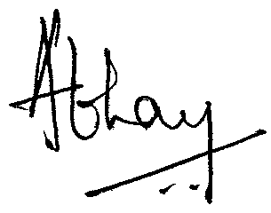
(Pratap) (Abhay)
Spokesperson, Spokesperson,
Central Regional Bureau Central Committee,
CPI (Maoist) CPI (Maoist)

