COMMITTEE FOR THE RELEASE OF POLITICAL PRISONERS
185/3, FOURTH FLOOR, ZAKIR NAGAR, NEW DELHI

21/09/09
PRESS STATEMENT
PRODUCE MR. KOBAD GANDHI, SENIOR MAOIST LEADER IMMEDIATELY BEFORE THE COURT!
ALL DEMOCRATIC FORCES SHOULD RAISE THEIR VOICE FOR HIS RIGHT TO A LAWYER AND PROTECTION FROM ALL FORMS OF TORTURE!

The committee for the Release of Political Prisoners views with concern the arrest and continuing illegal detention of Mr. Kobad Gandhi senior Maoist leader as is being reported by the press. He has been arrested by the Special Cell of the Delhi Police as per the press reports. The press has quoted the police as saying that he is member of the Polit Bureau of the CPI (Maoist). They have also revealed that Mr. Kobad Gandhi heads the publication division of the CPI (Maoist) and also it’s Sub-Committee on Mass Organizations.

The CRPP strongly demands that Mr. Kobad Gandhi be immediately produced before the court as we fear for the safety of his life. We also demand that he should be given the lawyer of his choice as per the law of this land. We at the CRPP call upon all democratic forces, civil rights groups and people’s organizations to raise their voice to defend the rights of Mr. Kobad Gandhi against all forms of torture and threat to his life.

In Solidarity,

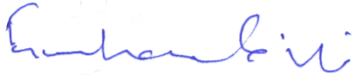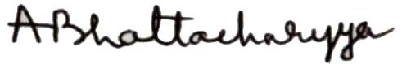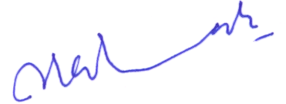
Gurusharan Singh Amit Bhattacharyya SAR Geelani
President Secretary General Vice President

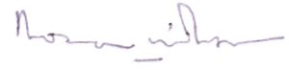
Rona Wilson
Secretary Public Relations

